- The C++ program given below is supposed to sort a 1D array of integers into ascending order. For example, {3, 2, 1} should become {1, 2, 3}.
#include <iostream>
using namespace std;

int main() // line 1
{
bool swapped = true;
int a[3] = {3, 2, 1};
int arraySize = 3;

while (swapped) // line 2
{
swapped = false; // line 3
for (int i = 1; i <= arraySize-1; i++) // line 4
{
if (a[i-1] > a[i]) // line 5
{
a[i] = a[i-1]; // line 6
a[i-1] = a[i]; // line 7
swapped = true; // line 8
} // line 9
} // line 10
} // line 11

// Output results
/*
for (int i = 0; i < arraySize; i++)
cout << a[i] << " ";
cout << endl;
*/
return(0); // line 12
}

Complete control flow graph for the code:
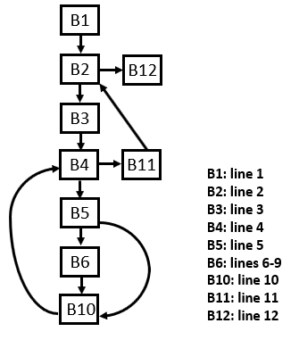
The code contains a bug (i.e., it does not produce correct results for some inputs). Given below are the results for 5 test cases including a code trace for each test case:
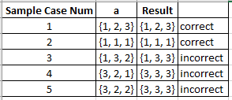
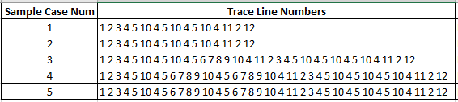
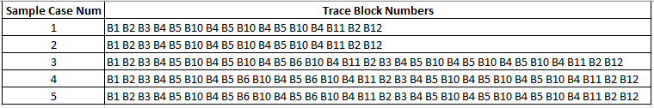

Control flow graph for traces 1 and 2 is shown below (the control flow graph for traces 3-5 is the same as the original control flow graph):
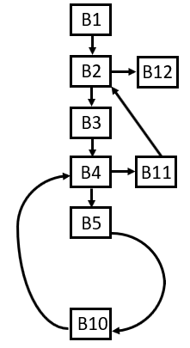
Control flow graphs with non-discriminative edges removed for traces 1 and 2 is the empty graph; the control flow graph for traces 3-5 with non-discriminative edges removed is:
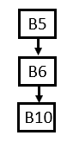
The above graph is the discriminative graph for the test cases that produced incorrect results.
Hence, the bug is in lines 5-10 of the code (namely, the code isn’t swapping a[i] and a[i-1] correctly).
Note: It might be good not to report B5 and B10 as being part of the suspicious code because they are being executed in all of the correct cases; that is, the code in those blocks are not where the bug occurs.

- The C++ program given below is supposed to replace only the 1st occurrence of either x or y with z in a 1D array of integers. For example, if x = 1, y = 2, and z = 0, the array {1, 2} should become {0, 2}.
#include <iostream>
using namespace std;

int main() // line 1
{
int x = 1;
int y = 2;
int z = 0;
int a[2] = {1, 2};
int arraySize = 2;

for (int i = 0; i < arraySize; i++) // line 2
{
if (a[i] == x) // line 3
{
a[i] = z; // line 4
} // line 5
if (a[i] == y) // line 6
{
a[i] = z; // line 7
} // line 8
} // line 9

// Output results
/*
for (int i = 0; i < arraySize; i++)
cout << a[i] << " ";
cout << endl;
*/
return(0); // line 10
}

Complete control flow graph for the code:
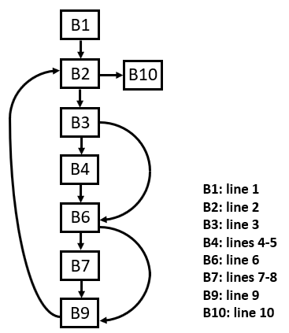

The code contains a bug (i.e., it does not produce correct results for some inputs). Given below are the results for 4 test cases including a code trace for each test case:
Test cases:
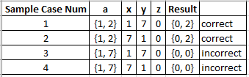
Corresponding traces:
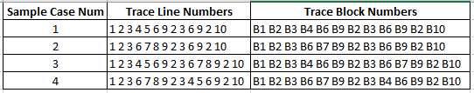

Control flow graphs for (a) trace 1 and (b) trace 2 (traces 3 and 4 are the same as the original control flow graph):
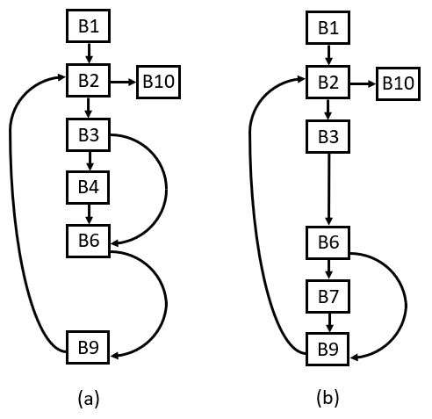

Control flow graphs with non-discriminative edges removed for (a) trace 1, (b) trace 2, and (c) traces 3 and 4:
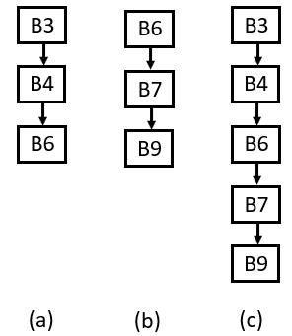

A discriminative graph for the test cases that produced incorrect results:
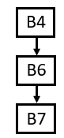
Hence, the bug is in lines 4-5, 6, and 7-8 of the code (namely, the bug is that it is replacing all occurrences of x and y with z; if it executes lines 4-5, it shouldn’t also be executing lines 6-8)

- The C++ program given below is supposed to determine how many times you can add a specified increment, staying under a specified maxSum and doing no more than maxAdditions many additions. For example, if increment is 2, maxAdditions is 4, and maxSum is 7, then you can only do 3 additions and your resulting sum will be 6.
#include <iostream>
using namespace std;

int main() // line 1
{
bool keepGoing = true;
int sum = 0;
int additions = 0;
int maxSum = 7;
int maxAdditions = 4;
int increment = 2;

while (keepGoing) // line 2
{
if (sum >= maxSum) // line 3
{
keepGoing = false; // line 4
} // line 5
else
{
if (additions >= maxAdditions) // line 6
{
keepGoing = false; // line 7
} // line 8
else
{
sum += increment; // line 9
additions++; // line 10
} // line 11
} // line 12
} // line 13

// Output results
/*
cout << sum << endl;
cout << additions << endl;
*/
return(0); // line 14
}

Complete control flow graph for the code:
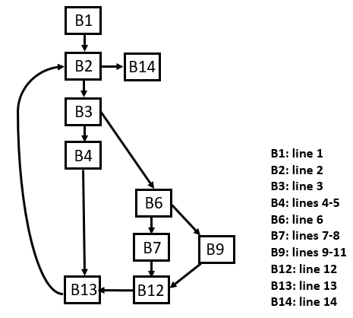

The code contains a bug (i.e., it does not produce correct results for some inputs). Given below are the results for 4 test cases including a code trace for each test case:
Test cases:
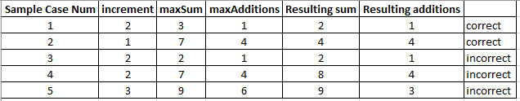
Corresponding traces:
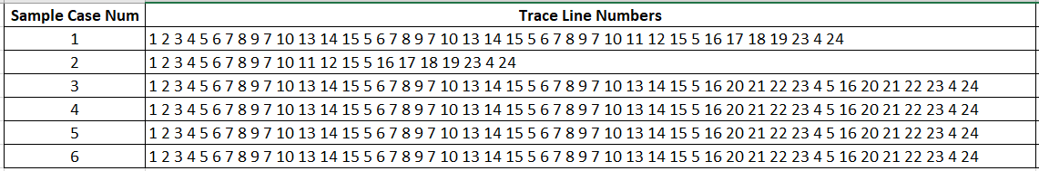

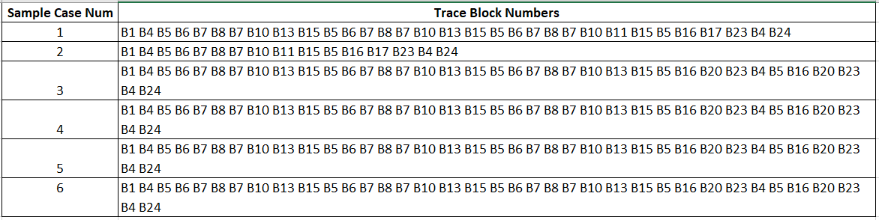

Control flow graphs for (a) traces 1 and 2, and (b) traces 3, 4, and 5:
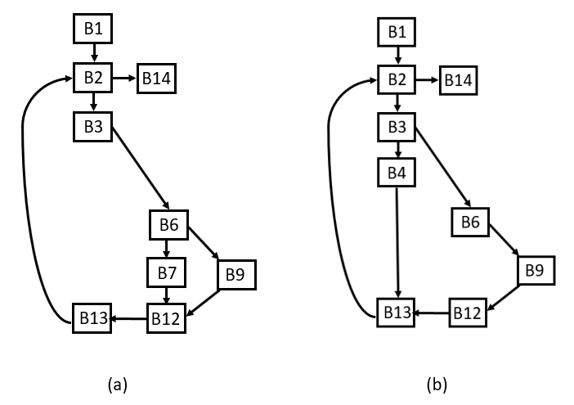
Control flow graphs with non-discriminative edges removed for (a) traces 1 and 2, and (b) traces 3, 4, and 5:
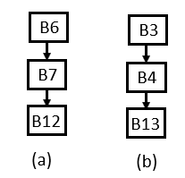
A discriminative graph for the test cases that produced incorrect results:
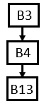
Hence, the bug is in lines 3, 4-5, and 13 of the code (namely, the bug is related to waiting until sum is greater than or equal to maxSum before setting the condition to terminate the loop; a fix would be to check in line 3 whether sum + increment >= maxSum)
- The C++ program given below is supposed to “flatten” and reverse the order of the elements of a given 2D array. By “flatten” we mean a n x m 2D array should become a vector of n * m elements. For example, {{1, 2}, {3, 4}, {5, 6}} should become {6, 5, 4, 3, 2, 1}.
int main() // line 1
{
int rowSize = 3;
int colSize = 2;
int a[3][2] = {{1, 2}, {3, 4}, {5, 6}};
int b[6] = {0,0,0,0,0,0};
int k;
int m;
int m_last = -1;

for (int i = 0; i < rowSize; i++) // line 2
{
for (int j = 0; j < colSize; j++) // line 3
{
m = i * rowSize + j; // line 4
if ((m >= rowSize * colSize) || (m <= m_last)) // line 5
{
m = 1; // line 6
} // line 7
k = rowSize * colSize - m - 1; // line 8
b[k] = a[i][j]; // line 9
m_last = m; // line 10
} // line 11
} // line 12

// Output results
/*
for (int i = 0; i < (rowSize * colSize); i++)
cout << b[i] << " ";
cout << endl;
*/
return(0); // line 13
}

Complete control flow graph for the code:
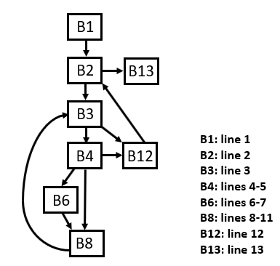

The code contains a bug (i.e., it does not produce correct results for some inputs). Given below are the results for 3 test cases including a code trace for each test case:
Test cases:
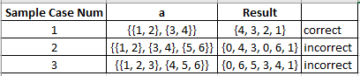
Corresponding traces:
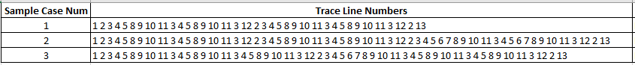

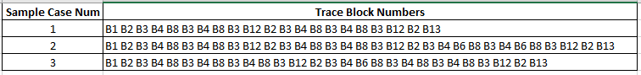

Control flow graphs for (a) trace 1, and (b) traces 2 and 3:
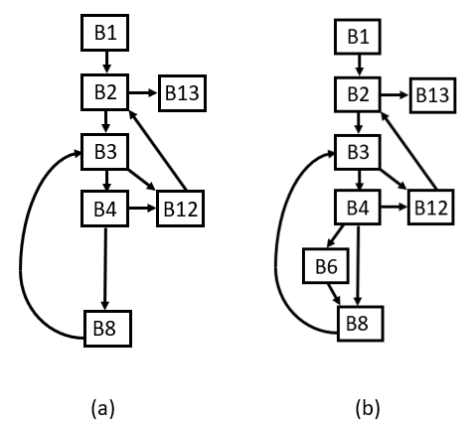
Control flow graphs with non-discriminative edges removed for (a) trace 1 and (b) traces 2 and 3:
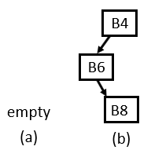
A discriminative graph for the test cases that produced incorrect results:
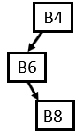
This indicates that the bug occurs when the sequence of lines 4-11 is executed This is somewhat misleading because the correct cases execute lines 4 (and 5) and lines 8-11 as well; the real difference is that the incorrect cases execute lines 6-7 and the correct cases do not. Lines 6-7 set the variable m to 1 if the computed value is not within the bound of the array or isn’t less than the last value of m (i.e., the code is supposed to be filling the array b in reverse order). Those lines are not actually the bug, but do indicate the general vicinity of the bug, namely that the formula for m in line 4 is not correct. The formula in line 4 should use colSize instead of rowSize. Anyway to better detect this???

- The C++ program given below is supposed to find the smallest sequential subsequence of integers in a 1D array whose sum is zero (if such a sequence exists). For example, in the array {2, 1, -1}, we can start at (0-based) index position 1 and use a sequential sequence of length 2 because 1 + -1 = 0. As another example, in the array {2, -1, 2}, there is no sequential sequence whose sum is 0, in which case we output a start position and sequence length of 0.
#include <iostream>
using namespace std;

int main() // line 1
{
int arraySize = 3;
int a[3] = {2, 1, -1};
int sum;
bool solutionFound;
int sequenceSize;
int start = 0;
int solutionStartAt = 0;
int solutionSequenceSize = 0;

solutionFound = false; // line 2
sequenceSize = 1; // line 3
while ((! solutionFound) && (sequenceSize < arraySize)) // line 4
{
while ((! solutionFound) && (start+sequenceSize <= arraySize)) // line 5
{
sum = 0; // line 6
for (int i = start; i < start+sequenceSize; i++) // line 7
{
sum += a[i]; // line 8
} // line 9
if (sum == 0) // line 10
{
solutionFound = true; // line 11
} // line 12
else
{
start++; // line 13
} // line 14
} // line 15
if (solutionFound) // line 16
{
solutionStartAt = start; // line 17
solutionSequenceSize = sequenceSize; // line 18
} // line 19
else
{
start = arraySize - 1; // line 20
sequenceSize++; // line 21
} // line 22
} // line 23

// Output results
/*
cout << "start = " << solutionStartAt
<< " sequence length = "
<< solutionSequenceSize << endl;
*/
return(0); // line 24
}

Complete control flow graph for the code:
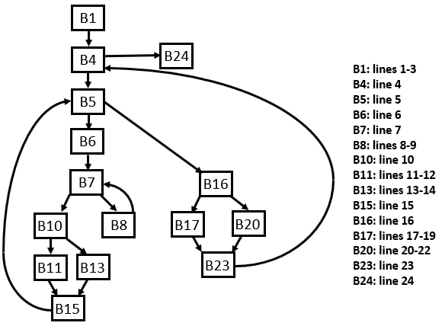

The code contains a bug (i.e., it does not produce correct results for some inputs). Given below are the results for test cases including a code trace for each test case:
Test cases:
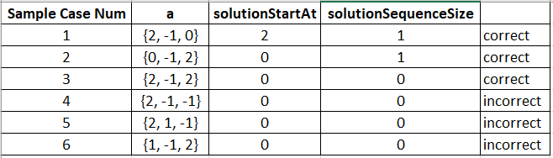
Corresponding traces:
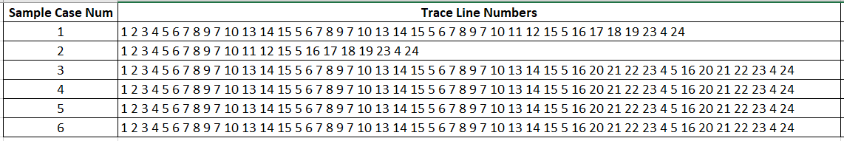

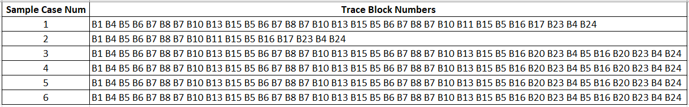

Control flow graphs for (a) trace 1, (b) trace2, and (c) traces 3-6:
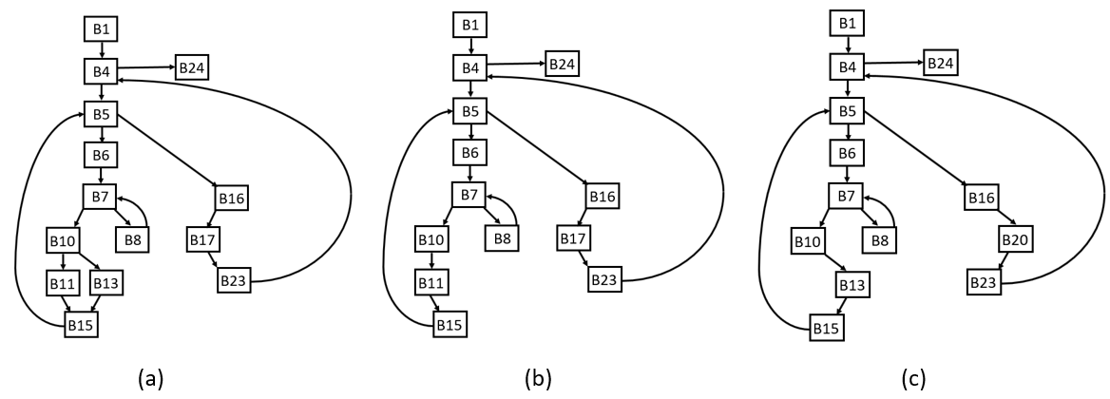

Control flow graphs with non-discriminative edges removed for (a) trace 1, (b) trace 2, and (c) traces 3-6:
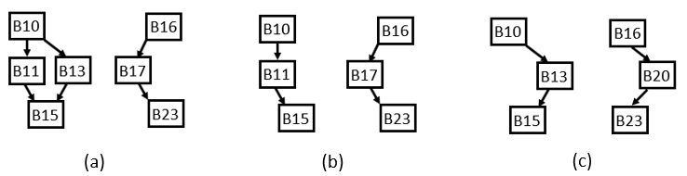
A discriminative graph for the test cases that produced incorrect results:
Empty; there is no subgraph that appears only in the faulty executions. However, if we relax this restriction somewhat and look for a subgraph that appears in all of the faulty executions but not in 2 of the 3 correct executions (i.e., doesn’t appear in case 3), then we get the following subgraph:
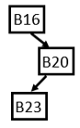
This indicates that the bug is within lines 20-23. That is indeed the vicinity of the bug; in line 20, it should be start = 0.
Note: It might be good not to report B16 and B23 as being part of the suspicious code because they are being executed in all of the correct cases; that is, the code in those blocks are not where the bug occurs.

- The C++ program given below is supposed to output the binary representation of a specified positive decimal number. For example, the output for the decimal number 39 should be 100111.
#include <iostream>
using namespace std;

int main() // line 1
{
int n = 1;
int m;
int sum;
int previous_power = 0;

while (n > 0) // line 2
{
m = 0; // line 3
if (n % 2) // line 4
{
sum = 1; // line 5
} // line 6
else
{
sum = 2; // line 7
} // line 8
while (sum * 2 <= n) // line 9
{
sum *= 2; // line 10
m++; // line 11
} // line 12
for (int gap = 1; gap < previous_power - m; gap++) // line 13
{
cout << 0; // line 14
} // line 15
cout << 1; // line 16
n = n - sum; // line 17
previous_power = m; // line 18
} // line 19
for (int trailingZero = m; trailingZero > 0; trailingZero--) // line 20
{
cout << 0; // line 21
} // line 22
cout << endl; // line 23

return(0); // line 24
}

Complete control flow graph for the code:
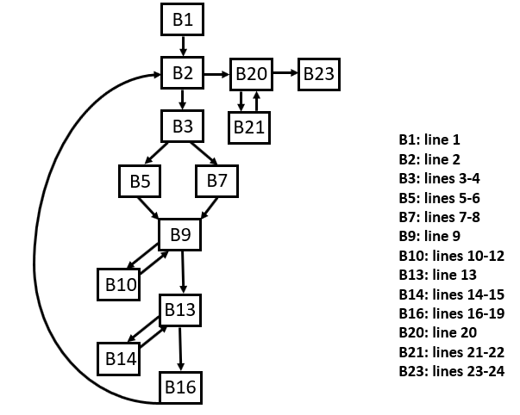
The code contains a bug (i.e., it does not produce correct results for some inputs). Given below are the results for 5 test cases including a code trace for each test case:
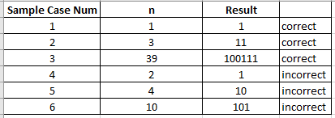
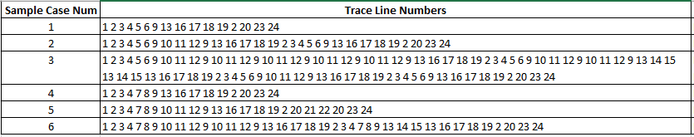
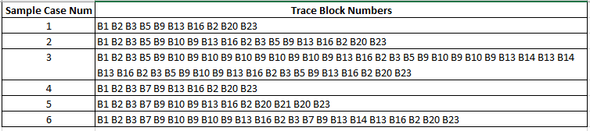

Control flow graphs for traces 1-6 shown as (a)-(g), respectively:
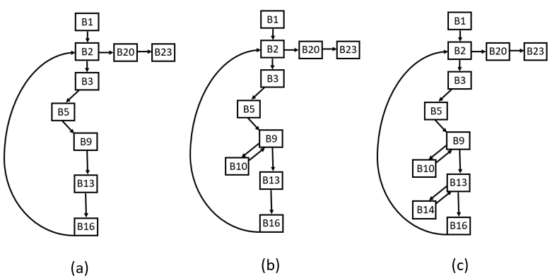
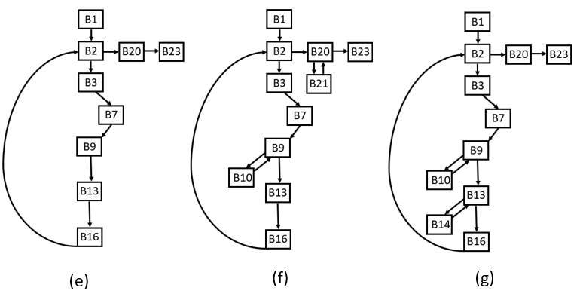

Control flow graphs for traces 1-6 with non-discriminant edges removed shown as (h)-(m), respectively:
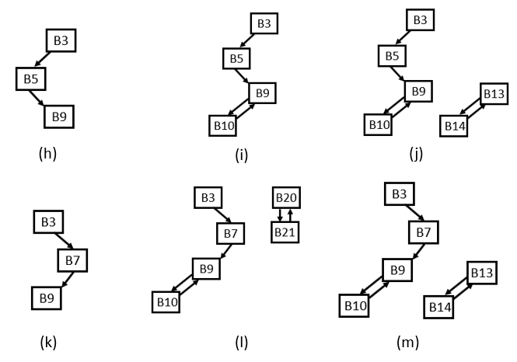
A discriminative graph for the test cases that produced incorrect results:
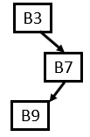
Hence, the bug is in lines 3-4 and 7-9 of the code. Line 3 (setting m = 0) is not the problem; the bug is actually in line 8 (and the condition being tested in line 4). The variable sum should never be set to 2, it should always be set to 1.
Note: It might be good not to report B3 and B9 as being part of the suspicious code because they are being executed in all of the correct cases; that is, the code in those blocks are not where the bug occurs.

